Selenium Guide
This document is prepared by Yogesh for the basic understanding of Selenium

Yogesh Ganesh Nipte
23 – December - 2018

This is personal document only for personal use

Contents

Contents 2
Driver 8
WebDrivder 8
Mozila Firefox 8
Google Chrome 8
Internet Explore 8
Wait 9
Types 9
Implicit Wait 9
Explicit Wait 9
Initialize 9
Wait conditions 9
Single Condition 10
Multiple Conditions 10
Elements 10
Single Element 10
Multiple Element 11
Navigate 11
Locating forms and sending user inputs 11
Clearing User inputs 11
Navigating backward in browser history 11
Navigating forward in browser history 11
Refresh/ Reload a web page 11
Closing Browser 11
Closing Browser and other all other windows associated with the driver 11
Moving between Windows 12
Moving between Frames 12
Moving between Frames using wait object 12
Moving between nested Frames 12
Drag and Drop 12
Select 14
Get All options 14
XPath 15
Image with alt tag value as One Travelex Logo 15
Text on page 15
Anchor contains text as GCSE 15
Search for tagname a and trim the text 15
Search preceding sibling of link text 1234 15
Accessing last cell of table 15
starts-with keyword 15
Contains 16
Following 16
Multiple condition 16
Partial match 16
starts-with 16
value has spaces 16
Sibling 17
lower-case 17
Parent 17
Concat 17
Table 18
Handling Alerts 20
void dismiss() 20
void accept() 20
String getText() 20
void sendKeys(String stringToSend) 20
Miscellaneous 21
Scrolling a web page 21
How to Handle Proxy in Selenium Webdriver 21
Handle Untrusted Certificate Selenium Webdriver 21
Highlight Element 21
Properties 22
Actions 23
Syntax 23
To perform mouse over 23
To perform shift +send keys 23
To select text from textbox 23
TestNG 24
TestNG Features 24
Benefits of Using Annotations 27
@Test(enabled = false) 30
@Test(priority=0) 30
@Test(timeOut = 10000) 31
@Test(groups = {"Sanity",”Smoke”}) 31
@Parameters({"URL"}) 31
Listeners 33
There are two main listeners. 33
What is Listeners in TestNG? 33
Types of Listeners in TestNG 33
ITestListener has following methods 34
Create Listener Class 35
Implementation of Listener 36
Listeners annotation 36
testng.xml and add listeners tag in XML 37
Use of Listener for multiple classes. 37
Dependency in TestNG 38
Create Test Suite 43
Create First Class 43
Create First Class xml 43
Create Second Class 43
Create second class xml 44
Create testing.xml 44
Output 44
Group Testing in TestNG 45
Cucumber 47
Feature File 47
Step Definition 48
Runner 49
Jenkins 51
Create Pipeline 51
Java Basics 53
Switch Case 53
Simple DateFormat Format Codes 53
Access Modifiers in java 55
private access modifier 55
default access modifier 55
protected access modifier 56
public access modifier 56
OOP 56
Inheritance 56
Polymorphism 56
Abstraction 56
Encapsulation 56
Apache POI 57
Reading data from file 57
Write data to test data 59
ExtentReport 61
Dependency 61
</dependency> 61
Code 61
HTML Report 62
63
Thread Safe 64
} 65
Framework 66
Packages 67
Classes in Framework 73
SeleniumDriver.java 73
TestsuiteBase 73
DevOps 74
What is DevOps? 74
Why is DevOps used? 75
Skills 77
Need to acquire 77
Database 79
Create Schema 79
Create Table 79
Insert Data 79
Docker 80
Commands 80
Java Code 81
Parallel Execution 83
Selenium Grid 83
Cloud 84
Robot Framework 85
Command line arguments 85
Script 86
Script level Set log level 87
Report 87
Automatic Variables 88
Custom Library 89
Libraries 89
Database Connection 90
Using Python 90
Code 91
Using Robot 92
Script 92
Result 92
Test Template 93
Protractor 94
Initial commands 94

Driver

import org.openqa.selenium.WebDriver;
import org.openqa.selenium.chrome.ChromeDriver;
import org.openqa.selenium.firefox.FirefoxDriver;
import org.openqa.selenium.ie.InternetExplorerDriver;

WebDrivder
WebDriver driver;

Mozila Firefox
driver = new FirefoxDriver();

Google Chrome
System.setProperty("webdriver.chrome.driver", "D:\\Selenium Jars\\Driver\\chromedriver.exe");
driver = new ChromeDriver();

Internet Explore
System.setProperty("webdriver.ie.driver", "D:\\Selenium Jars\\Driver\\ie.exe");
driver = new InternetExplorerDriver();

Wait

Types
- Implicit Wait
- Explicit Wait
- WebDriverWait
- FluentWait

Implicit Wait

driver.manage().timeouts().implicitlyWait(10, TimeUnit.SECONDS);

Explicit Wait

Fluent Wait is useful in following scenario .
Consider you click on Order summary page which comes after 5 sec and after few seconds Payment page appear but both button have same property

import org.openqa.selenium.support.ui.WebDriverWait;

Initialize

WebDriverWait wait = new WebDriverWait(driver, 900);

Wait conditions

import org.openqa.selenium.support.ui.ExpectedCondition;
import org.openqa.selenium.support.ui.ExpectedConditions;

Single Condition

wait.until(ExpectedConditions.elementToBeClickable(By.xpath("//button[@id='markAsPaidModalBtn']")));

Multiple Conditions

ExpectedConditions.or
ExpectedConditions.and
wait.until(
ExpectedConditions.or(

ExpectedConditions.elementToBeClickable(By.xpath("//button[@id='markAsPaidModalBtn']")),
ExpectedConditions.presenceOfElementLocated(By.xpath("//button[@id='markAsPaidModalBtn'])"))
)
);

Elements

import org.openqa.selenium.By;
import org.openqa.selenium.WebElement;
import java.util.List;

Single Element

driver.findElement(By.xpath("//*[contains(text(),'Drafts')]")).click();

Multiple Element

List<WebElement> objLinks = driver.findElements(By.xpath("//a"));
System.out.println(objLinks.size());

for (WebElement objLink : objLinks) {
System.out.println(objLink.getAttribute("text"));
}

Navigate
driver.navigate().to("https://javatpoint.com/selenium-tutorial");

Locating forms and sending user inputs
driver.findElement(By.id("lst-ib")).sendKeys("javatpoint tutorials");

Clearing User inputs
driver.findElement(By.name("q")).clear();

Navigating backward in browser history
driver.navigate().back();

Navigating forward in browser history
driver.navigate().forward();

Refresh/ Reload a web page
driver.navigate().refresh();

Closing Browser
driver.close();

Closing Browser and other all other windows associated with the driver
driver.quit();

Moving between Windows
windowsid = new ArraList(driver.getWindowHandles());
/// to switch to first child window
Driver.switchTo().window(windowsid.get(1))
driver.switchTo().window("windowName");

Moving between Frames
driver.switchTo().frame("frameName");

Moving between Frames using wait object
In this case script will wait till frame gets loaded and if conditions gets true it automatically switch to the frame
Wait.until(ExpectedConditions.frameToBeAvailableAndSwitchToIt(Locator)

Moving between nested Frames
driver.switchTo().frame("frameName");
// nested iframe has css locator name
WebElement element = driver.findElement(By.cssSelector(“name”))
//We need to use frame(Webelement) method
Driver.switchTo().frame(WebElement);

Drag and Drop
WebElement element = driver.findElement(By.name("source"));
WebElement target = driver.findElement(By.name("target"));

(new Actions(driver)).dragAndDrop(element, target).perform();

Select
import org.openqa.selenium.support.ui.Select;

Select objSelect = new Select(driver.findElement(By.xpath("//*[@id='title']")));

objSelect.selectByIndex(2);

objSelect.selectByValue("6");

objSelect.selectByVisibleText("Dr.");

Get All options

List<WebElement> options = objSelect.getOptions();
int intSize = options.size();

for(int i=0; i<intSize; i++) {
String value = options.get(i).getText();
System.out.println(value);
}

XPath

Image with alt tag value as One Travelex Logo
//img[contains(@alt,'One Travelex Logo')]

Text on page
//*[text()='Awards']

Anchor contains text as GCSE
//a[contains (text(),'GCSE')]

Search for tagname a and trim the text
//a[text()[normalize-space(.)='1234']]
//text()[normalize-space()='automation']

Search preceding sibling of link text 1234
//a[text()[normalize-space(.)='1234']]/preceding-sibling::input[1]

= | Roger Federer | 17 | 0 | 0 | 17 | 2003–2012

Accessing last cell of table
.//*[@id='mw-content-text']//td[normalize-space(text())="2003–2012"]/preceding-sibling::td[last()-1]

starts-with keyword
//a[starts-with(.,'Frank')]
It will find out the links that starts with Frank eg Frank Woolley , Frank Worrell

Contains
//tr[descendant::a[contains(.,'testing')]]//input[@type='radio']

.//*[contains(@id,'rblProductTypes_0')]

.//text()[contains(.,'automation')]

Following
Search for Total Text and get next value
Table Search
//*[@id='order']//tr//td[contains(text(),'Total:')]/following::td[1]

Multiple condition
//div[@class='bubble-title' and contains(text(), 'Cover')]

Partial match
//span[contains(text(), 'Assign Rate')]

starts-with
//input[starts-with(@id,'reportcombo')

value has spaces
//div[./div/div[normalize-space(.)='More Actions...']]

Sibling
//td[.='LoadType']/following-sibling::td[1]/select"

lower-case
By.xpath("//td[contains(lower-case(text()),'youruser')]")
//to handle case sensitivity. Here user is not case sensitive

Parent
//*[@id='selcrit']//td[1]/a[text()[normalize-space(.)='582900']]/parent::*

Concat
//a[contains(text(),concat('#','44030'))]"

Table

GUI Element | Corresponding XPath | Remarks
<input type="submit" value="Save"/> | //input[@value="Save"] | Exactly matches the text "Save"
<input type="submit" value="Save1"/>  <input type="submit" value="Save2"/> | (//input)[1] matches the 1st input element, "Save1"  (//input)[2] matches the 2nd input element, "Save2"
<a href="somelink">Structure</a> | //a[text()="Structure"] | Exactly matches the value within a given tag. Here the text "Structure" which is in between the <a> tag (anchor tag)
<a href="somelink">x_structure_y</a> | //a[contains(text(),'structure')] | Like wildcard search, matches the input element which has the text "structure" within a given tag
<input type="button" name="ccd_ccd_81533739_removeevent"/> | //input[contains(@name,concat("ccd","_","ccd","_")) and contains(@name,"removeevent")]  Note: The above xpath can be used when the attribute value has a part which is dynamic in nature (here in this case the text in between "ccd_" and "_removeevent" '81533739" keeps on changing everytime the GUI element is accessed) | Matching multiple text(s) pattern of a attribute value
<input type="text" value="Search..."/> | //input[@type='text' and contains(@value,'Search')] | Matches based on multiple attributes of a GUI element . Here the xpath of the text box is derived based on its 'type' and 'value' attributes

Xpath axis Name | Description
self | Which contains only the context node
ancestor | contains the ancestors of the context node, that is, the parent of the context node, its parent, etc., if it has one.
ancestor-or-self | contains the context node and its ancestors
attribute | contains all the attribute nodes, if any, of the context node
child | contains the children of the context node
descendant | contains the children of the context node, the children of those children, etc.
descendant-or-self | contains the context node and its descendants
following | contains all nodes which occur after the context node, in document order
following-sibling | Selects all siblings after the current node
namespace | contains all the namespace nodes, if any, of the context node
parent | Contains the parent of the context node if it has one
preceding | contains all nodes which occur before the context node, in document order
preceding-sibling | contains the preceding siblings of the context node

Handling Alerts

import org.openqa.selenium.Alert;

void dismiss()

driver.switchTo().alert().dismiss();

void accept()

driver.switchTo().alert().accept();

String getText()

driver.switchTo().alert().getText();

void sendKeys(String stringToSend)

driver.switchTo().alert().sendKeys("Text");

Miscellaneous

Scrolling a web page

JavascriptExecutor js = (JavascriptExecutor)driver;
js.executeScript("scrollBy(0, 4500)");

How to Handle Proxy in Selenium Webdriver

Change the proxy setting using Webdriver code.
Proxy p = new Proxy();
p.setHttpProxy("localhost:7777");
DesiredCapabilities cap = new DesiredCapabilities();
cap.setCapability(CapabilityType.PROXY, p);
driver = new ChromeDriver(cap);

Handle Untrusted Certificate Selenium Webdriver

DesiredCapabilities cap = DesiredCapabilities.chrome();
cap.setCapability(CapabilityType.ACCEPT_SSL_CERTS,true);
driver = new ChromeDriver(cap);

Highlight Element

WebElement element = driver.findElement(By.name("uid"));
JavascriptExecutor js = (JavascriptExecutor) driver;
js.executeScript("arguments[0].setAttribute('style', 'background: yellow; border: 2px solid red;');", element);

Properties

Create Env.properties file
File
#Sucess
#Wed Jan 09 07:14:49 EST 2019
FirstName=Yogesh
LastName=Nipate

Code
import java.io.FileOutputStream;
import java.io.OutputStream;
import java.util.Properties;

public class TestingData {

public static void main(String[] args) {
// TODO Auto-generated method stub
Properties prop = new Properties();
OutputStream out = null;
try {
out = new FileOutputStream("data\\Env.properties");
prop.setProperty("FirstName","Yogesh");
prop.setProperty("LastName","Nipate");
prop.store(out, "Sucess");
System.out.println(prop.get("LastName"));

}catch(Exception e) {

}
}

}

Actions

Syntax
Actions action = new Actions(driver);
WebElement Account = driver.findElement(By.xpath("//*[contains(text(),'Account & Lists')]"));

To perform mouse over

action.moveToElement(Account).build().perform();

To perform shift +send keys

action.moveToElement(Search).click().keyDown(Keys.SHIFT).sendKeys("mobile").build().perform();

To select text from textbox

action.moveToElement(Search).click().keyDown(Keys.SHIFT).sendKeys("mobile")
.doubleClick().build().perform();

TestNG

TestNG Features

Supports annotations.
TestNG uses more Java and OO features.
Supports testing integrated classes (e.g., by default, no need to create a new test class instance for every test method).
Separates compile-time test code from run-time configuration/data info.
Flexible runtime configuration.
Introduces ‘test groups’. Once you have compiled your tests, you can just ask TestNG to run all the "front-end" tests, or "fast", "slow", "database" tests, etc.
Supports Dependent test methods, parallel testing, load testing, and partial failure.
Flexible plug-in API.
Support for multi-threaded testing.

Sr.No. | Annotation & Description
1 | @BeforeSuite  The annotated method will be run only once before all tests in this suite have run.
2 | @AfterSuite  The annotated method will be run only once after all tests in this suite have run.
3 | @BeforeClass  The annotated method will be run only once before the first test method in the current class is invoked.
4 | @AfterClass  The annotated method will be run only once after all the test methods in the current class have run.
5 | @BeforeTest  The annotated method will be run before any test method belonging to the classes inside the <test> tag is run.
6 | @AfterTest  The annotated method will be run after all the test methods belonging to the classes inside the <test> tag have run.
7 | @BeforeGroups  The list of groups that this configuration method will run before. This method is guaranteed to run shortly before the first test method that belongs to any of these groups is invoked.
8 | @AfterGroups  The list of groups that this configuration method will run after. This method is guaranteed to run shortly after the last test method that belongs to any of these groups is invoked.
9 | @BeforeMethod  The annotated method will be run before each test method.
10 | @AfterMethod  The annotated method will be run after each test method.
11 | @DataProvider  Marks a method as supplying data for a test method. The annotated method must return an Object[ ][ ], where each Object[ ] can be assigned the parameter list of the test method. The @Test method that wants to receive data from this DataProvider needs to use a dataProvider name equals to the name of this annotation.
12 | @Factory  Marks a method as a factory that returns objects that will be used by TestNG as Test classes. The method must return Object[ ].
13 | @Listeners  Defines listeners on a test class.
14 | @Parameters  Describes how to pass parameters to a @Test method.
15 | @Test  Marks a class or a method as a part of the test.

Benefits of Using Annotations

Following are some of the benefits of using annotations −
- TestNG identifies the methods it is interested in, by looking up annotations. Hence, method names are not restricted to any pattern or format.
- We can pass additional parameters to annotations.
- Annotations are strongly typed, so the compiler will flag any mistakes right away.
- Test classes no longer need to extend anything (such as TestCase, for JUnit 3).

import org.junit.AfterClass;
import org.junit.BeforeClass;
import org.testng.annotations.AfterMethod;
import org.testng.annotations.AfterSuite;
import org.testng.annotations.AfterTest;
import org.testng.annotations.BeforeMethod;
import org.testng.annotations.BeforeSuite;
import org.testng.annotations.BeforeTest;
import org.testng.annotations.Test;

public class TestngAnnotation {
// test case 1
@Test
public void testCase1() {
System.out.println("in test case 1");
}

// test case 2
@Test
public void testCase2() {
System.out.println("in test case 2");
}

@BeforeMethod
public void beforeMethod() {
System.out.println("in beforeMethod");
}

@AfterMethod
public void afterMethod() {
System.out.println("in afterMethod");
}

@BeforeClass
public void beforeClass() {
System.out.println("in beforeClass");
}

@AfterClass
public void afterClass() {
System.out.println("in afterClass");
}

@BeforeTest
public void beforeTest() {
System.out.println("in beforeTest");
}

@AfterTest
public void afterTest() {
System.out.println("in afterTest");
}

@BeforeSuite
public void beforeSuite() {
System.out.println("in beforeSuite");
}

@AfterSuite
public void afterSuite() {
System.out.println("in afterSuite");
}

}

Output
[RemoteTestNG] detected TestNG version 6.14.2
in beforeSuite
in beforeTest
in beforeMethod
in test case 1
in afterMethod
in beforeMethod
in test case 2
in afterMethod
in afterTest
PASSED: testCase1
PASSED: testCase2

===============================================
Default test
Tests run: 2, Failures: 0, Skips: 0
===============================================

in afterSuite

===============================================
Default suite
Total tests run: 2, Failures: 0, Skips: 0

Based on the above output, the execution procedure is as follows −
- First of all, beforeSuite() method is executed only once.
- Lastly, the afterSuite() method executes only once.
- Even the methods beforeTest(), beforeClass(), afterClass(), and afterTest() methods are executed only once.
- beforeMethod() method executes for each test case but before executing the test case.
- afterMethod() method executes for each test case but after executing the test case.
- In between beforeMethod() and afterMethod(), each test case executes.

@Test(enabled = false)

Sometimes, it happens that our code is not ready and the test case written to test that method/code fails. In such cases, annotation @Test(enabled = false) helps to disable this test case.
If a test method is annotated with @Test(enabled = false), then the test case that is not ready to test is bypassed.

@Test(enabled=false)
public void testCase1() {
System.out.println("in test case 1");
}

@Test(priority=0)

In case priority is not set then the test scripts execute in alphabetical order.

@Test(priority=1)
Public void Ford(){
System.out.println("in test case Ford");

}
@Test(priority=2)
Public void Ferrari(){
System.out.println("in test case Ferrari");

}
Output
in test case Ford
in test case Ferrari

@Test(timeOut = 10000)

@Test(timeOut = 100000)
public void TimeoutTest() {
System.out.println("---- Timeout Test -----------");
}

@Test(groups = {"Sanity",”Smoke”})

@Test(groups = {"Sanity"})
public void loginTest() {
System.out.println("----- Inside Login Test Sanity Group");
}

Testing.xml
<suite thread-count="2" name="Suite" parallel="methods">
<test thread-count="2" name="Test" parallel="methods">
<groups>
<run>
<include name="Sanity" />
</run>
</groups>
<classes>
<class name="com.test.first.NewTest" />
</classes>
</test> <!-- Test -->
</suite> <!-- Suite -->

@Parameters({"URL"})

@Parameters({"URL","Name"})
@Test
public void ParameterTest(String url,String name) {
System.out.println("----- ParameterTest ------- ");
System.out.println("URL is "+url);
System.out.println("Name is "+name);
}

<suite thread-count="2" name="Suite" parallel="methods">
<parameter name="URL" value="https://www.icicibank.com" />
<parameter name="Name" value="Yogesh" />
<test thread-count="2" name="Test" parallel="methods">
<classes>
<class name="com.test.first.NewTest" />
</classes>
</test> <!-- Test -->
</suite> <!-- Suite -->

Listeners

There are two main listeners.
- WebDriver Listeners
- TestNG Listeners

What is Listeners in TestNG?
Listener is defined as interface that modifes the default TestNG's behavior. As the name suggests Listeners "listen" to the event defined in the selenium script and behave accordingly. It is used in selenium by implementing Listeners Interface. It allows customizing TestNG reports or logs. There are many types of TestNG listeners available.

Types of Listeners in TestNG
There are many types of listeners which allows you to change the TestNG's behavior.
Below are the few TestNG listeners:
IAnnotationTransformer ,
IAnnotationTransformer2 ,
IConfigurable ,
IConfigurationListener ,
IExecutionListener,
IHookable ,
IInvokedMethodListener ,
IInvokedMethodListener2 ,
IMethodInterceptor ,
IReporter,
ISuiteListener,
ITestListener .

ITestListener has following methods

OnStart- OnStart method is called when any Test starts.
onTestSuccess- onTestSuccess method is called on the success of any Test.
onTestFailure- onTestFailure method is called on the failure of any Test.
onTestSkipped- onTestSkipped method is called on skipped of any Test.
onTestFailedButWithinSuccessPercentage- method is called each time Test fails but is within success percentage.
onFinish- onFinish method is called after all Tests are executed.

Create Listener Class

package com.listener.test;
import org.junit.runner.Result;
import org.testng.ITestContext;
import org.testng.ITestListener;
import org.testng.ITestResult;
import org.testng.Reporter;

public class ListenerTest implements ITestListener {

@Override
public void onTestStart(ITestResult result) {
// TODO Auto-generated method stub

}

@Override
public void onTestSuccess(ITestResult result) {
// TODO Auto-generated method stub

}

@Override
public void onTestFailure(ITestResult result) {
// TODO Auto-generated method stub
System.out.println("The name of the testcase failed is :");
Reporter.log("Testcase failed");

}

@Override
public void onTestSkipped(ITestResult result) {
// TODO Auto-generated method stub

}

@Override
public void onTestFailedButWithinSuccessPercentage(ITestResult result) {
// TODO Auto-generated method stub

}

@Override
public void onStart(ITestContext context) {
// TODO Auto-generated method stub

}

@Override
public void onFinish(ITestContext context) {
// TODO Auto-generated method stub

}}

Implementation of Listener

- Listeners annotation
- testng.xml and add listeners tag in XML

Listeners annotation

@Listeners(Listener_Demo.ListenerTest.class)
package com.listener.test;

import org.openqa.selenium.By;
import org.openqa.selenium.WebDriver;
import org.openqa.selenium.chrome.ChromeDriver;
import org.testng.Reporter;
import org.testng.annotations.AfterTest;
import org.testng.annotations.Listeners;
import org.testng.annotations.Test;

@Listeners(com.listener.test.ListenerTest.class)

public class TestCases {

WebDriver driver;

@Test
public void testLogin()
{
String strPath = System.getProperty("user.dir");
System.out.println(strPath);
Reporter.log(strPath);
System.setProperty("webdriver.chrome.driver", strPath+"\\driver\\chromedriver.exe");
Reporter.log("setProperty");
driver = new ChromeDriver();
driver.get("http://demo.guru99.com/V4/");
Reporter.log("navigate");
driver.findElement(By.name("uid")).sendKeys("mngr34926");
Reporter.log("uid");
driver.findElement(By.name("password")).sendKeys("amUpenu");
Reporter.log("password1");
driver.findElement(By.id("1")).click();
Reporter.log("Login button");
}

}

testng.xml and add listeners tag in XML

<?xml version="1.0" encoding="UTF-8"?>
<!DOCTYPE suite SYSTEM "http://testng.org/testng-1.0.dtd">
<suite thread-count="2" name="Suite" parallel="methods">
<listeners>
<listener class-name="com.listener.test.ListenerTest"></listener>
</listeners>
<!-- <test thread-count="2" name="Test" parallel="methods"> -->
<test name="test">
<classes>
<class name="com.listener.test.TestCases"/>
</classes>
</test> <!-- Test -->
</suite> <!-- Suite -->

Use of Listener for multiple classes.

If project has multiple classes adding Listeners to each one of them could be cumbersome and error prone.

In such cases, we can create a testng.xml and add listeners tag in XML.

This listener is implemented throughout the test suite irrespective of the number of classes you have. When you run this XML file, listeners will work on all classes mentioned. You can also declare any number of listener class.

Dependency in TestNG

@Test(dependsOnMethods="startApp")
public void loginApp() {
}
This test is dependent on result of startApp Test. If startApp test passed then only this test will be executed else it will be skipped.

package com.testng.test;

import org.testng.annotations.Test;
import static org.testng.Assert.assertEquals;
import static org.testng.Assert.assertTrue;

import org.openqa.selenium.By;
import org.openqa.selenium.WebDriver;
import org.openqa.selenium.chrome.ChromeDriver;
import org.openqa.selenium.support.ui.ExpectedConditions;
import org.openqa.selenium.support.ui.WebDriverWait;
import org.testng.Assert;
import org.testng.Reporter;
import org.testng.annotations.AfterSuite;
import org.testng.annotations.AfterTest;
import org.testng.annotations.BeforeTest;
import org.testng.annotations.Test;
import org.testng.log4testng.Logger;

public class DependencyTest {

WebDriver driver;
WebDriverWait wait;

@BeforeTest
public void initializeDriver() {
System.out.println("inside startApp");
String path = System.getProperty("user.dir");
System.out.println(path+"\\drivers\\chromedriver.exe");
System.setProperty("webdriver.chrome.driver", path+"\\drivers\\chromedriver.exe");
driver = new ChromeDriver();
wait = new WebDriverWait(driver,30);
}

@Test()
public void startApp() {
driver.manage().window().maximize();
driver.get("https://strade.sharekhan.com/rmmweb/login/OldLoginPage.jsp?e=1");
wait.until(ExpectedConditions.presenceOfElementLocated(By.xpath("//*[@id='loginid']")));
System.out.println(driver.getTitle());
//Assert.assertEquals(driver.getTitle().toString().contains("Login"), "Login");
//Assert.assertTrue(driver.getTitle().toString().contains("Login"), "Login");
if(driver.getTitle().toString().contains("Login")) {
Assert.assertTrue(true);
}
else {
Assert.assertTrue(false);
}
Reporter.log(driver.getTitle());
}

@Test(dependsOnMethods="startApp")
public void loginApp() {
System.out.println("inside loginApp");
driver.findElement(By.xpath("//*[@id='loginid']")).sendKeys("88yogeshn");
driver.findElement(By.xpath("//*[@id='pwSignup']")).sendKeys("Yogi5@3688");
driver.findElement(By.xpath("//*[@id='pwSignup1']")).sendKeys("URGQQQ");
driver.findElement(By.xpath("//*[@name='Login']")).click();
wait.until(ExpectedConditions.elementToBeClickable(By.xpath("//a[contains(text(),'Logout')]")));
System.out.println(driver.getTitle());
//Assert.assertEquals(driver.getTitle().toString().contains("jungle"),"sharekhan.com, your guide to financial jungle");
//Assert.assertEquals(driver.findElement(By.xpath("//a[contains(text(),'Logout')]")).isDisplayed(),"Logout");
//Assert.assertTrue(driver.getTitle().toString().contains("jungle"),"sharekhan.com, your guide to financial jungle");
if(driver.getTitle().toString().contains("jungle")) {
Assert.assertTrue(true);
}
else {
Assert.assertTrue(false);
}
Reporter.log(driver.getTitle());
}

@Test(dependsOnMethods="loginApp")
public void logoutApp() {
System.out.println("inside logoutApp");
driver.findElement(By.xpath("//a[contains(text(),'Logout')]")).click();
try {
Thread.sleep(10000);
}catch(Exception e) {

}
System.out.println(driver.getTitle());
//Assert.assertEquals(driver.getTitle().toString().contains("Sharekhan"),"Sharekhan");
if(driver.getTitle().toString().contains("Sharekhan")) {
Assert.assertTrue(true);
}
else {
Assert.assertTrue(false);
}
Reporter.log("Logout Sucessfully");
Reporter.log(driver.getTitle());
}

@AfterTest
public void closeSession() {
System.out.println("inside closeSession");
driver.close();
driver.quit();
}
}

Create Test Suite

Create First Class

package com.suite.tc;

import org.testng.annotations.Test;

public class Amazon {

@Test
public void tcFirst() {
System.out.println(" -------------- Amazon tcFirst ------------------");
}
}

Create First Class xml

<?xml version="1.0" encoding="UTF-8"?>
<!DOCTYPE suite SYSTEM "http://testng.org/testng-1.0.dtd">
<suite name="Amazon">
<test name="Amazon">
<classes>
<class name="com.suite.tc.Amazon"></class>
</classes>
</test>
</suite>

Create Second Class

package com.suite.tc;

import org.testng.annotations.Test;

public class Flipkart {

@Test
public void tcFirst() {
System.out.println(" -------------- inside Flipkart tcFirst ---------------");
}
}

Create second class xml

<?xml version="1.0" encoding="UTF-8"?>
<!DOCTYPE suite SYSTEM "http://testng.org/testng-1.0.dtd">
<suite name="Flipkart">
<test name="Flipkart">
<classes>
<class name="com.suite.tc.Flipkart"></class>
</classes>
</test>
</suite>

Create testing.xml

<?xml version="1.0" encoding="UTF-8"?>
<!DOCTYPE suite SYSTEM "http://testng.org/testng-1.0.dtd">

<suite thread-count="2" name="Suite" parallel="methods">
<suite-files>
<suite-file path="./Flipkart.xml"></suite-file>
<suite-file path="./Amazon.xml"></suite-file>
</suite-files>
</suite>

Output

[RemoteTestNG] detected TestNG version 6.14.2
-------------- inside Flipkart tcFirst ---------------

===============================================
Flipkart
Total tests run: 1, Failures: 0, Skips: 0
===============================================

-------------- Amazon tcFirst ------------------

===============================================
Amazon
Total tests run: 1, Failures: 0, Skips: 0
===============================================

===============================================
Suite
Total tests run: 2, Failures: 0, Skips: 0
===============================================

Group Testing in TestNG

TestNG Groups:
TestNG allows you to perform sophisticated groupings of test methods. Not only can you declare that methods belong to groups, but you can also specify groups that contain other groups. Then TestNG can be invoked and asked to include a certain set of groups (or regular expressions) while excluding another set. This gives you maximum flexibility in how you partition your tests and doesn’t require you to recompile anything if you want to run two different sets of tests back to back.

package com.listener.test;

import org.testng.annotations.Test;

public class GroupTest1 {

@Test(groups = {"Sanity"})
public void testLoginApp() {
System.out.println("---- Inside testLoginApp ----------------");
}
}

package com.listener.test;

import org.testng.annotations.Test;

public class GroupTest2 {

@Test(groups = {"Smoke"})
public void testHomePageApp() {
System.out.println("---- Inside testHomePageApp --------------");
}
}

Testing.xml
<suite thread-count="2" name="Group" parallel="methods">
<test name="GroupTesting">
<groups>
<run>
<include name="Smoke"></include>
</run>
</groups>

<classes>
<class name ="com.listener.test.GroupTest1"> </class>
<class name ="com.listener.test.GroupTest2"> </class>
</classes>
</test>
</suite>

Cucumber

Three components
- .feature file
- Step Definition
- Runner

Feature File

Each feature file has
- Feature : This is nothing but Test Scenario
- Scenario : This is a Test Case
- Given : Pre condition of you test case
- When : Test Case Steps
- And : Test case steps required for When
- Then : The final steps in Test case
- Scenario Outline : This is use for Data Driver Scenario

Feature: Checking Kite Functionality

Scenario: Verify Login Functionality

Given Kite_I open chrome browser
When Kite_I naviagate to "https://inrprepaid.icicibank.com/customer/login.jsp"
And Kite_I enter user id "NIPATEYG3688" and password "yogi20038980509" and click Login button
And Kite_I enter Pin "060592" and click on continue button
Then Kite_click on Logout
Then Close the Browser

Step Definition

In Step Definition file we write methods which are nothing but statements present in Feature file with tags (@Given,@When,@Then)

public class KiteStepDefination {

private WebDriver driver;
private DriverServices service;
private IReader readConfigFile;

public KiteStepDefination(DriverServices service) {
this.service = service;
this.driver = service.getDriver();
this.readConfigFile = service.getiReadder();
}

@Given("^Kite_I open chrome browser$")
public void kite_i_open_chrome_browser() throws Throwable {
//service.getObjBrowserHelper().getInstance(driver);
}

@When("^Kite_I naviagate to \"([^\"]*)\"$")
public void kite_i_naviagate_to(String url) throws Throwable {
//driver.get(url);
driver.get(readConfigFile.getApplicationURL());
}

@When("^Kite_I enter user id \"([^\"]*)\" and password \"([^\"]*)\" and click Login button$")
public void kite_i_enter_user_id_and_password_and_click_Login_button(String userid, String password) throws Throwable {
service.getObjTextBoxHelper().setText(By.xpath("//*[@id='j_username_pick']"), readConfigFile.getUsername());
service.getObjTextBoxHelper().setText(By.xpath("//*[@id='j_userpassword_pick_chrome']"), readConfigFile.getPassword());

}

@When("^Kite_I enter Pin \"([^\"]*)\" and click on continue button$")
public void kite_i_enter_Pin_and_click_on_continue_button(String arg1) throws Throwable {
service.getObjButtonHelper().clickButton(By.xpath("//*[@id='loginbtnbg']"));
}

@Then("^Kite_click on Logout$")
public void kite_click_on_Logout() throws Throwable {
service.getObjButtonHelper().clickButton(By.xpath("//a[contains(text(),'Logout')]"));
}

@Then("^Close the Browser$")
public void close_the_Browser() throws Throwable {

}

@Then("^Kite_TakeScreenshot of page$")
public void kite_takescreenshot_of_page() throws Throwable {
Timestamp timestamp = new Timestamp(System.currentTimeMillis());
String filename = timestamp.toString().replaceAll("[^\\\\.A-Za-z0-9_]", "_").replace(".", "_");
service.getGenericHelper().takeScreenshot("Screenshots", filename);

}

}

Runner

In Runner file we specify different configurations like features - feature file path , glue - Step definition,
Plugin – report format, tags – What type of tests that need to execute like Smoke, Regression etc
package Runners;

---------------------------------------------------- CODE -----------------------------------------------------
import cucumber.api.CucumberOptions;
import cucumber.api.testng.AbstractTestNGCucumberTests;

@CucumberOptions(
features = {"src/test/java/Features/Kite.feature"},
glue = {"StepDefination","com.base.generatehook"},
dryRun = false,
monochrome = true,
//plugin = {"pretty","html:Results/HTMLReport"}
plugin = {"pretty","html:Results/HTMLReport","junit:Results/JUnitReport/index.xml"}
//tags = {"@regression"} // will execute @regreesion scenarios from feature file
)
public class KiteRunner extends AbstractTestNGCucumberTests {

}

Jenkins

Create Pipeline

Plugin : Build Pipeline Plugin
Create .jenkinsfile as per below format
pipeline
{
agent any

stages
{
stage('Build')
{
steps
{
echo 'Build process'
}
}
stage('Deploy')
{
steps
{
echo 'Deploy process'
}
}
stage('Test')
{
steps
{
echo 'Test process'
}
}

}
}

Java Basics

Switch Case

Date objDate = new Date();
SimpleDateFormat fr1 = new SimpleDateFormat("E yyyy.MM.dd 'at' hh:mm:ss a zzz");
System.out.println(fr1.format(objDate));
SimpleDateFormat fr = new SimpleDateFormat("MM");
System.out.println(fr.format(objDate));
String intMonth = fr.format(objDate);
switch(intMonth) {
case "01" :
System.out.println("Jan");
break;
case "02" :
System.out.println("Feb");
break;
case "03" :
System.out.println("Mar");
break;
case "04" :
System.out.println("Jun");
break;
case "05" :
System.out.println("Jul");
}

Simple DateFormat Format Codes
To specify the time format, use a time pattern string. In this pattern, all ASCII letters are reserved as pattern letters, which are defined as the following –

Character | Description | Example
G | Era designator | AD
y | Year in four digits | 2001
M | Month in year | July or 07
d | Day in month | 10
h | Hour in A.M./P.M. (1~12) | 12
H | Hour in day (0~23) | 22
m | Minute in hour | 30
s | Second in minute | 55
S | Millisecond | 234
E | Day in week | Tuesday
D | Day in year | 360
F | Day of week in month | 2 (second Wed. in July)
w | Week in year | 40
W | Week in month | 1
a | A.M./P.M. marker | PM
k | Hour in day (1~24) | 24
K | Hour in A.M./P.M. (0~11) | 10
z | Time zone | Eastern Standard Time
' | Escape for text | Delimiter
" | Single quote | `

Access Modifiers in java
There are 4 types of java access modifiers:
- private
- default
- protected
- public

private access modifier
- The private access modifier is accessible only within class.
- A class contains private data member and private method. We are accessing these private members from outside the class, so there is compile time error
- If you make any class constructor private, you cannot create the instance of that class from outside the class

default access modifier
- If you don't use any modifier, it is treated as default bydefault. The default modifier is accessible only within package.

protected access modifier
- The protected access modifier is accessible within package and outside the package but through inheritance only.

public access modifier
- The public access modifier is accessible everywhere. It has the widest scope among all other modifiers.

OOP

Inheritance
When one object acquires all the properties and behaviors of a parent object, it is known as inheritance. It provides code reusability. It is used to achieve runtime polymorphism.

Polymorphism
If one task is performed by different ways, it is known as polymorphism. For example: to convince the customer differently, to draw something, for example, shape, triangle, rectangle, etc

Abstraction
Hiding internal details and showing functionality is known as abstraction. For example phone call, we don't know the internal processing.
In Java, we use abstract class and interface to achieve abstraction.

Encapsulation
Binding (or wrapping) code and data together into a single unit are known as encapsulation. For example capsule, it is wrapped with different medicines
A java class is the example of encapsulation. Java bean is the fully encapsulated class because all the data members are private here

Apache POI

Reading data from file

public HashMap readData(String sheetName,int rownumber) {
File file = new File("");
System.out.println(file.getAbsolutePath());
String excelFile = file.getAbsolutePath()+"/data/Security.xlsx";
HashMap<String,String> data = new HashMap<String, String>();
try {
// Connect to data file xls
FileInputStream fis = new FileInputStream(excelFile);
// Create workbook object
Workbook workbook = new XSSFWorkbook(fis);
//Create sheet object
Sheet sheet = workbook.getSheet(sheetName);
//Get Column count of first Row
int intFirstRowColumn = sheet.getRow(0).getPhysicalNumberOfCells();
System.out.println("Column count of row 1 is "+intFirstRowColumn);
//Get Column count of requested Row
int intDataRowColumn = sheet.getRow(rownumber).getPhysicalNumberOfCells();
System.out.println("Column count of row "+rownumber+" is "+intDataRowColumn);

//Reading cell data and storing it in HashMap <String , String>
for(int c=0; c<intFirstRowColumn; c++) {
String key = sheet.getRow(0).getCell(c).toString();
String value = sheet.getRow(rownumber).getCell(c).toString();
System.out.println("Key : "+key+" value : "+value);
data.put(key, value);
}
sheet = null;
workbook = null;
fis = null;
}catch(Exception e) {
e.printStackTrace();
}
return data;
}

Write data to test data

public void writeData(String sheetName, int rowNumber,String data) {
File file = new File("");
System.out.println(file.getAbsolutePath());
String excelFile = file.getAbsolutePath() + "/data/Security.xlsx";
try {
// Connect to data file xls
FileInputStream fis = new FileInputStream(excelFile);
// Create workbook object
Workbook workbook = new XSSFWorkbook(fis);
// Create sheet object
Sheet sheet = workbook.getSheet(sheetName);
Row row = sheet.getRow(rowNumber);
Cell cell = row.createCell(17);
cell.setCellValue(data);
CellStyle style = workbook.createCellStyle();
if(data.toLowerCase().contains("pass")) {
style.setFillBackgroundColor(IndexedColors.GREEN.getIndex());
}
FileOutputStream fout = new FileOutputStream(excelFile);
workbook.write(fout);
fout.close();
sheet = null;
workbook = null;
fis = null;

} catch (Exception e) {
e.printStackTrace();
}
}

ExtentReport

Dependency

<dependency>
<groupId>com.aventstack</groupId>
<artifactId>extentreports</artifactId>
<version>5.0.4</version>

</dependency>

Code

ExtentReports extent;

@BeforeTest
public void config() {
String path = System.getProperty("user.dir")+"\\ExtentReports\\index.html";
ExtentSparkReporter reporter = new ExtentSparkReporter(path);
reporter.config().setReportName("My Test Report");
reporter.config().setDocumentTitle("Test Automation");
extent = new ExtentReports();
extent.attachReporter(reporter);
extent.setSystemInfo("Tester", "Yogi");
}

@Test
public void SeleniumDemo() {
// extent.createTest("Extent Report Demo");
ExtentTest test = extent.createTest("Extent Report Demo");

File path = new File("").getAbsoluteFile();
System.out.println(path);
String url = "https://www.ultimatix.net/";
System.setProperty("webdriver.chrome.driver", path + "\\drivers\\chromedriver83.exe");
WebDriver driver = new ChromeDriver();
driver.manage().window().maximize();
driver.get(url);
System.out.println(driver.getTitle());
test.addScreenCaptureFromBase64String(driver.getTitle());

driver.quit();
extent.flush();
}

HTML Report
Test
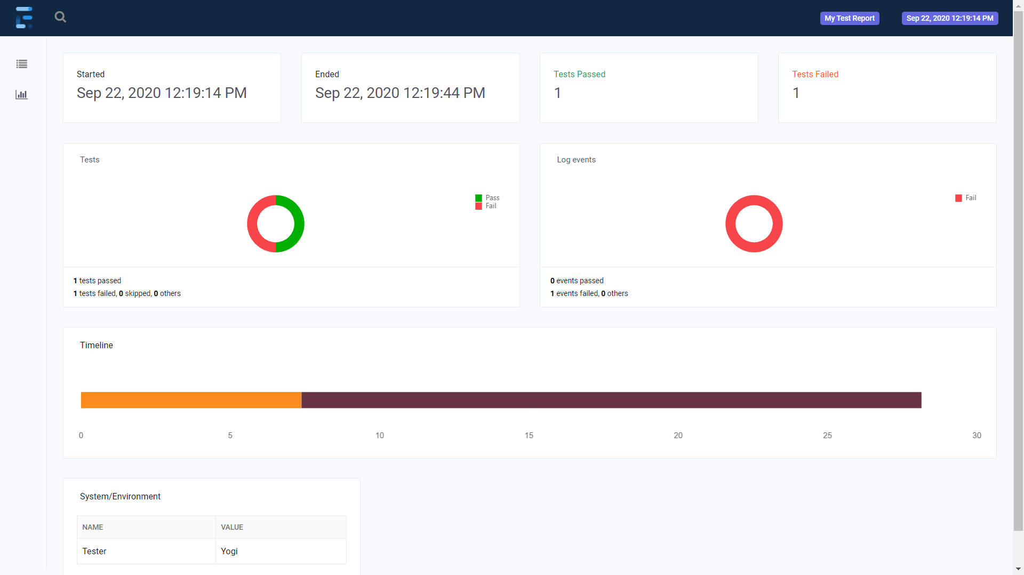

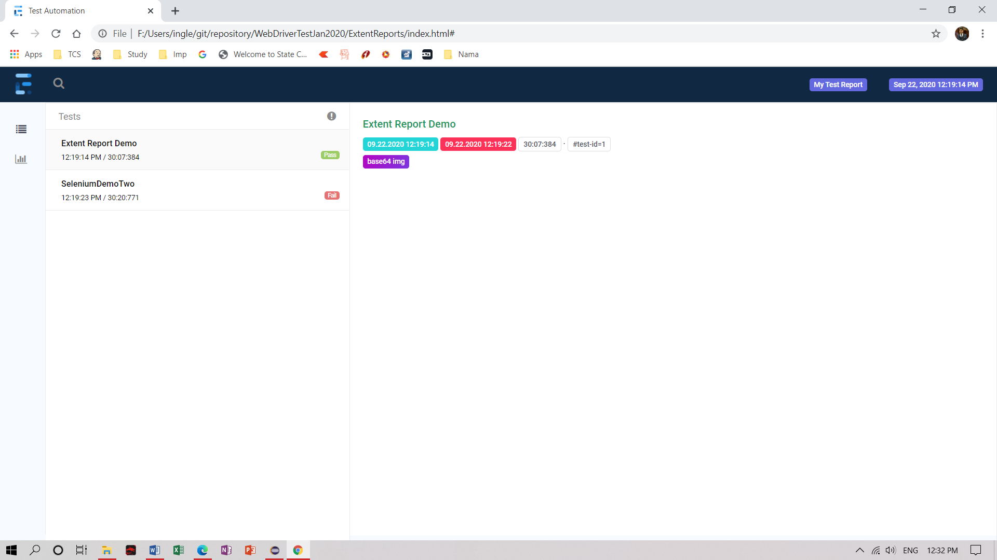

Thread Safe

ThreadLocal is class require to make object thread safe.
This class provides thread local variable. These variables differ from their normal counterparts in that each thread that accesses one (via its get or set method) has its own, independently initialized copy of the variable.
- Basically it is an another way to achieve thread safety apart from writing immutable classes.
- Since Object is no more shared there is no requirement of Synchronization which can improve scalability and performance of application.
- It extends class Object.
- ThreadLocal provides thread restriction which is extension of local variable. ThreadLocal are visible only in single thread. No two thread can see each others thread local variable.
- These variable are generally private static field in classes and maintain its state inside thread

public class Listeners extends Base implements ITestListener {

ExtentReports extent = ExtenntReporterNG.getReportObject();
ExtentTest test;
// To make extent object thread safe
ThreadLocal<ExtentTest> extentTest = new ThreadLocal<ExtentTest>();
public void onTestStart(ITestResult result) {
// TODO Auto-generated method stub
String testname = result.getMethod().getMethodName();
test = extent.createTest(testname);
// Thread local pull store all the
extentTest.set(test);
}

public void onTestSuccess(ITestResult result) {
// TODO Auto-generated method stub
extentTest.get().log(Status.PASS, "Test Passed");
}

public void onTestFailure(ITestResult result) {
// TODO Auto-generated method stub
extentTest.get().fail(result.getThrowable());
WebDriver driver = null;
try {
String testname = result.getMethod().getMethodName();
// result.getTestClass().getRealClass().getDeclaredField("filename").get(result.getInstance());
driver = (WebDriver) result.getTestClass().getRealClass().getDeclaredField("driver")
.get(result.getInstance());
getScreenshotPath(testname, driver);
} catch (Exception e) {
e.printStackTrace();
}
}

public void onTestSkipped(ITestResult result) {
// TODO Auto-generated method stub
}

public void onTestFailedButWithinSuccessPercentage(ITestResult result) {
// TODO Auto-generated method stub
}

public void onTestFailedWithTimeout(ITestResult result) {
// TODO Auto-generated method stub
}

public void onStart(ITestContext context) {
// TODO Auto-generated method stub
}

public void onFinish(ITestContext context) {
// TODO Auto-generated method stub
extent.flush();

}

Framework

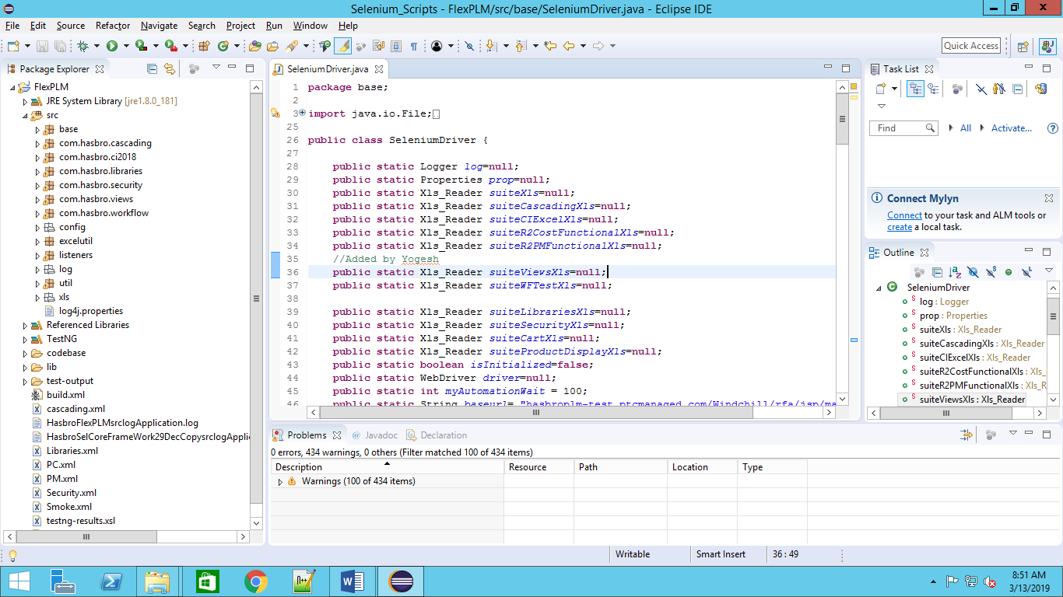

Packages
base – It contains driver script SeleniumDriver.java

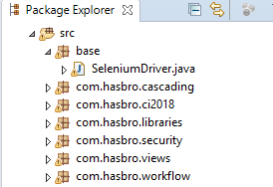
com.hasbro.security – It contains actual scripts like BOM,Color,Colorway,Country,Material etc

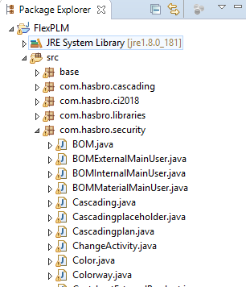
config : it contains config.properties files

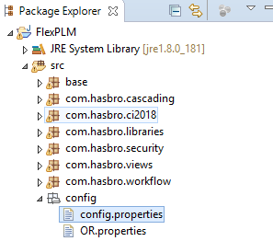

exelutil : It contains files required for excel read and write operation.
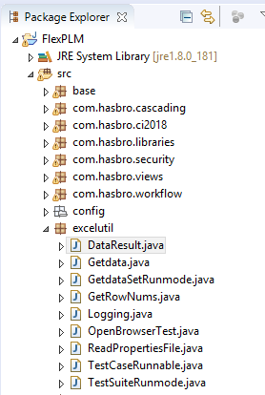

listeners: it contains files like
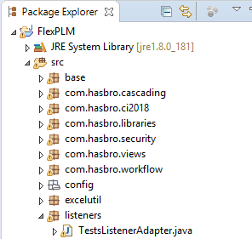

log : it contains Application.log generated during execution from log.info statement .

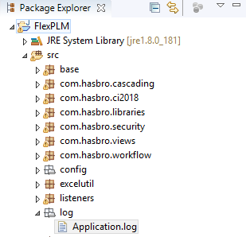
util : It contains files like
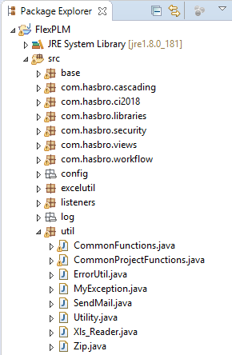

Xls : It contains TestData ie xls files
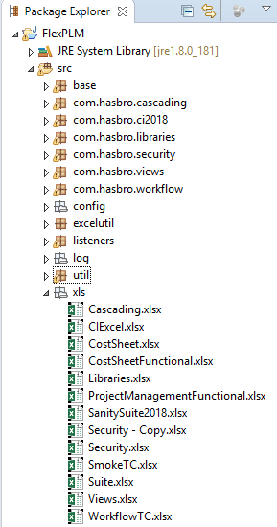

Xml : xml files are testing.xml
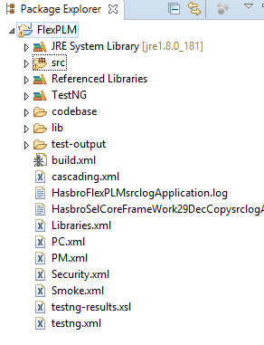

Classes in Framework

SeleniumDriver.java

It is used for initialize datasheet ( xls files) using Xls_Reader() method & opening the browser using openBrowser() , close browser using cloaseBrowser()
It contains following method
- initialize()
- openBrowser()
- launchApp(String username,String password)
- closeBrowser()

Code snippet
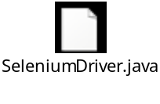

TestsuiteBase

DevOps

What is DevOps?

DevOps is a culture which promotes collaboration between Development and Operations Team to deploy code to production faster in an automated & repeatable way. The word 'DevOps' is a combination of two words 'development' and 'operations.'
DevOps helps to increases an organization's speed to deliver applications and services. It allows organizations to serve their customers better and compete more strongly in the market.
In simple words, DevOps can be defined as an alignment of development and IT operations with better communication and collaboration.
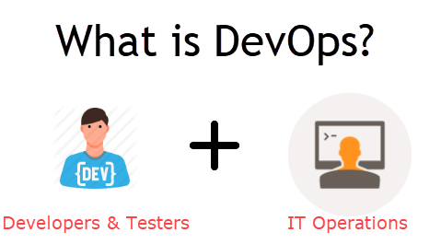
Why is DevOps is Needed?
Before DevOps, the development and operation team worked in complete isolation.
Testing and Deployment were isolated activities done after design-build. Hence they consumed more time than actual build cycles.
Without using DevOps, team members are spending a large amount of their time in testing, deploying, and designing instead of building the project.
Manual code deployment leads to human errors in production
Coding & operation teams have their separate timelines and are not in synch causing further delays.

There is a demand to increase the rate of software delivery by business stakeholders. As per Forrester Consulting Study, Only 17% of teams can use delivery software fast enough. This proves the pain point.

Why is DevOps used?

DevOps allows Agile Development Teams to implement Continuous Integration and Continuous Delivery. This helps them to launch products faster into the market.
Other Important reasons are:
1. Predictability: DevOps offers significantly lower failure rate of new releases
2. Reproducibility: Version everything so that earlier version can be restored anytime.
3. Maintainability: Effortless process of recovery in the event of a new release crashing or disabling the current system.
4. Time to market: DevOps reduces the time to market up to 50% through streamlined software delivery. This is particularly the case for digital and mobile applications.
5. Greater Quality: DevOps helps the team to provide improved quality of application development as it incorporates infrastructure issues.
6. Reduced Risk: DevOps incorporates security aspects in the software delivery lifecycle. It helps in reduction of defects across the lifecycle.
7. Resiliency: The Operational state of the software system is more stable, secure, and changes are auditable.
8. Cost Efficiency: DevOps offers cost efficiency in the software development process which is always an aspiration of IT companies' management.
9. Breaks larger code base into small pieces: DevOps is based on the agile programming method. Therefore, it allows breaking larger code bases into smaller and manageable chunks.

Skills

- HP UFT
- HP ALM
- Selenium using Java
- Core Java
- TestNG
- Selenium using Python
- Robot Framework
- API Testing
- Cucumber
- Git basic command
- Jenkins Basic

Need to acquire

- SQL
- Linux
- Protractor
- Appium
- Manual Testing
- DevOps
- Unix Shell Scripting
- RPA
- Windows Batch Job
- GoLang
- Docker

Database

Create Schema

Create schema schema_name;

Create Table

CREATE TABLE CustomerInfo
( CourseName varchar (50),
PurchaseData date,
Amount int(50),
Location varchar(50) );

Insert Data

insert into bussiness.customerinfo values ( 'GoLang',Current_Date(), 30, 'Africa' );

Docker

Commands

docker - - version

To verify container running status
docker ps

to pull image from hub
docker pull <image-name>
docker pull selenium/standalone-chrome:85.0

To verify images present
docker images

To run container

$ docker run -d -p 4444:4444 -v /dev/shm:/dev/shm <image_name>:<version>

$ docker run -d -p 4444:4444 -v /dev/shm:/dev/shm selenium/standalone-chrome:latest

$ docker run -d -p 4444:4444 -v /dev/shm:/dev/shm selenium/standalone-chrome:4.0.0-alpha-7-prerelease-20200907

Java Code

To implement selenium code
- Create URL object
- Create DesiredCapabilities object
- Create RemoteWebDriver object

import java.net.MalformedURLException;
import java.net.URL;
import org.openqa.selenium.remote.DesiredCapabilities;
import org.openqa.selenium.remote.RemoteWebDriver;

public class ChromeStandaloneTest {
public static void main(String[] args) throws MalformedURLException {
// TODO Auto-generated method stub
URL url = new URL("http://localhost:4444/wd/hub");
DesiredCapabilities cap = DesiredCapabilities.chrome();
RemoteWebDriver driver = new RemoteWebDriver(url,cap);
String myUrl = "https://www.icicibank.com";
driver.get(myUrl);
driver.manage().window().maximize();
System.out.println(driver.getCurrentUrl());
System.out.println(driver.getTitle());
driver.close();
}

}

Parallel Execution

Selenium Grid

- Download selenium-server-standalone-3.141.59.jar
- Open cmd , Start hub using following
- Java –jar selenium-server-standalone-3.141.59.jar –role hub
- 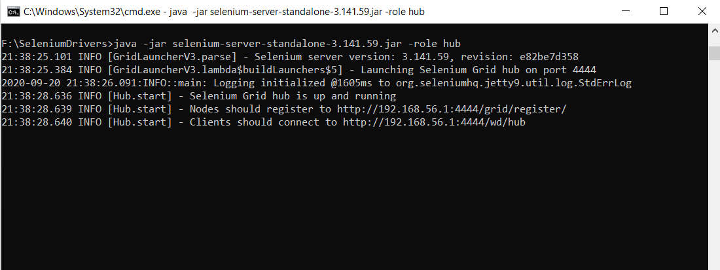
- Open cmd , Register node using following command
- Java –jar selenium-server-standalone-3.141.59.jar –role node –hub http://localhost:4444/grid/register
- 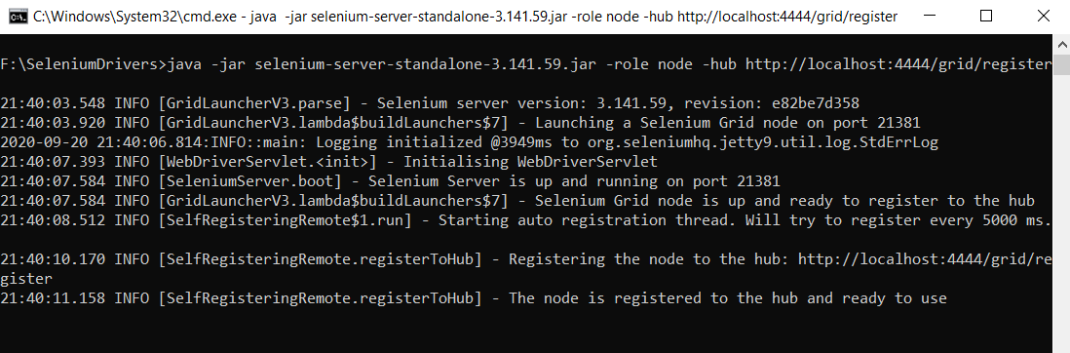

Cloud

- BrowserStack
https://www.browserstack.com/
- SAUCELABS
  - https://saucelabs.com/

Robot Framework

Command line arguments

Robot –d Result –i TagName –N “Report title”–t TestName --randomize suite|test –L debug Folder1/Folder2/FileName.robot

Tip : If Parameter contains spaces then use double quotes (“”)
Eg . Robot –i “Smoke” –t “My Test Case”

-d Result – To store Results
-i TagName – This is to specify which tag of Testcases to execute
-t TestName
-N “Custmize Report Name”
--randomize suite|test – To set random execution of Suite or Tests

Script

*** Settings ***
Documentation This is first testcase
Library SeleniumLibrary
Suite Setup MY SUITE SETUP
Suite Teardown MY SUITE TEARDOWN
Test Setup MY TEST SETUP
Test Teardown CLOSE BROWSERS
*** Test Cases ***
TC_01_ICICI_HOME_PAGE
[Documentation] This is ICICI home page
[Tags] Sanity
OPEN BROWSER AND NAVIGATE https://www.icicibank.com chrome
TC_02_HDFC_HOME_PAGE
[Documentation] This is HDFC Bank home page
[Tags] Smoke
OPEN BROWSER AND NAVIGATE https://www.hdfcbank.com chrome
*** Keywords ***
OPEN BROWSER AND NAVIGATE
[Arguments] ${url} ${browser}
open browser ${url} ${browser}
maximize browser window
log get title
CLOSE BROWSERS
close all browsers
MY TEST SETUP
log ${TEST_NAME}
MY SUITE SETUP
log My suite setup
MY SUITE TEARDOWN
log My Suite Teardown

Script level Set log level

To set debug in Script
*** Test Cases ***
TC_01_SET_LOG_LEVEL_DEBUG
[Documentation] This is ICICI home page
[Tags] Sanity
Comment set debug log level
set log level Debug
OPEN BROWSER AND NAVIGATE https://www.icicibank.com chrome
set log level info

Report

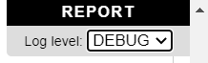

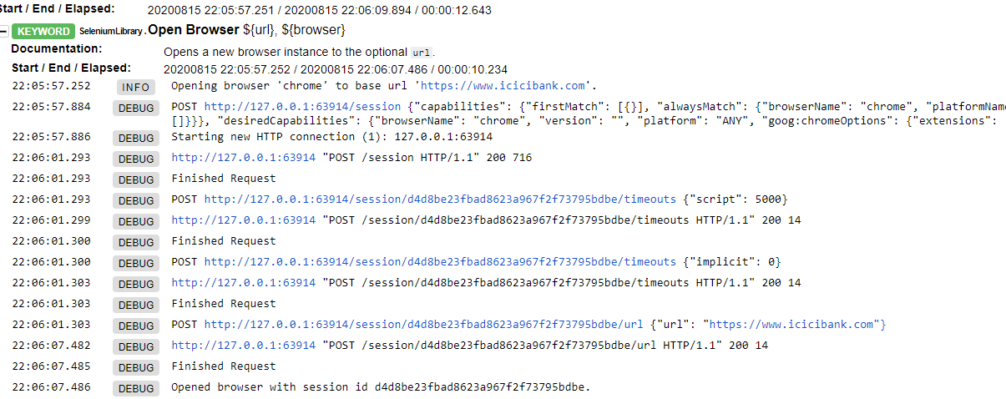

Automatic Variables

Variable | Explanation | Available
${TEST NAME} | The name of the current test case. | Test case
@{TEST TAGS} | Contains the tags of the current test case in alphabetical order. Can be modified dynamically using Set Tags and Remove Tags keywords. | Test case
${TEST DOCUMENTATION} | The documentation of the current test case. Can be set dynamically using using Set Test Documentation keyword. | Test case
${TEST STATUS} | The status of the current test case, either PASS or FAIL. | Test teardown
${TEST MESSAGE} | The message of the current test case. | Test teardown
${PREV TEST NAME} | The name of the previous test case, or an empty string if no tests have been executed yet. | Everywhere
${PREV TEST STATUS} | The status of the previous test case: either PASS, FAIL, or an empty string when no tests have been executed. | Everywhere
${PREV TEST MESSAGE} | The possible error message of the previous test case. | Everywhere
${SUITE NAME} | The full name of the current test suite. | Everywhere
${SUITE SOURCE} | An absolute path to the suite file or directory. | Everywhere
${SUITE DOCUMENTATION} | The documentation of the current test suite. Can be set dynamically using using Set Suite Documentation keyword. | Everywhere
&{SUITE METADATA} | The free metadata of the current test suite. Can be set using Set Suite Metadata keyword. | Everywhere
${SUITE STATUS} | The status of the current test suite, either PASS or FAIL. | Suite teardown
${SUITE MESSAGE} | The full message of the current test suite, including statistics. | Suite teardown
${KEYWORD STATUS} | The status of the current keyword, either PASS or FAIL. | User keyword teardown
${KEYWORD MESSAGE} | The possible error message of the current keyword. | User keyword teardown
${LOG LEVEL} | Current log level. | Everywhere
${OUTPUT FILE} | An absolute path to the output file. | Everywhere
${LOG FILE} | An absolute path to the log file or string NONE when no log file is created. | Everywhere
${REPORT FILE} | An absolute path to the report file or string NONE when no report is created. | Everywhere
${DEBUG FILE} | An absolute path to the debug file or string NONE when no debug file is created. | Everywhere
${OUTPUT DIR} | An absolute path to the output directory. | Everywhere

Custom Library
Import MyLibrary.py file
GET CURRENT TIME
Get Current

This function is created in MyLibrary.py file
def get_current():
return (datetime.datetime.now())

Keyword Get Current become get_current() functions

Libraries

- Standard
- External
- Other

Database Connection

Using Python
Python connector
pip install mysql-connector-python

- Steps to connect MySQL database in Python using MySQL Connector Python
- Install MySQL Connector Python using pip.
- Use the mysql.connector.connect() method of MySQL Connector Python with required parameters to connect MySQL.
- Use the connection object returned by a connect() method to create a cursor object to perform Database Operations.
- The cursor.execute() to execute SQL queries from Python.
- Close the Cursor object using a cursor.close() and MySQL database connection using connection.close() after your work completes.
- Catch Exception if any that may occur during this process.

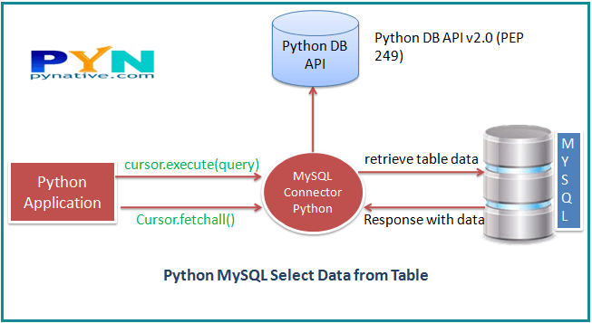

Code
import mysql.connector
from mysql.connector import Error
try:
connection = mysql.connector.connect( host='localhost',
database='bussiness',
user='root',
password='root')
if(connection.is_connected()):
db_info = connection.get_server_info()
print("Connected to MySQL DB Server Version",db_info)
sql_query = "Select * from customerinfo"
cursor = connection.cursor()
cursor.execute(sql_query)
records = cursor.fetchall()
print("Total number of rows in customerinfo is: ", cursor.rowcount)
print("Column Names are: ", cursor.column_names)
for row in records:
print("Course Name ",row[0],)
print("Purchased Date ", row[1])
except Error as e:
print("Error while connecting to Database",e)
finally:
if(connection.is_connected()):
cursor.close()
connection.close()
print("MySQL connection is closed")

Using Robot

pip install -U robotframework-databaselibrary

Script

*** Settings ***
Library DatabaseLibrary
*** Variables ***
${dbname} bussiness
${dbuser} root
${dbpassword} root
${dbhost} localhost
${dbport} 3306
@{QueryResult}
*** Test Cases ***
TC_01_CONNECT_DATABASE
Connect to database pymysql ${dbname} ${dbuser} ${dbpassword} ${dbhost} ${dbport}
table must exist customerinfo
check if exists in database Select * from customerinfo
@{QueryResult} QUERY Select * from customerinfo
LOG @{QueryResult}[0]

Result
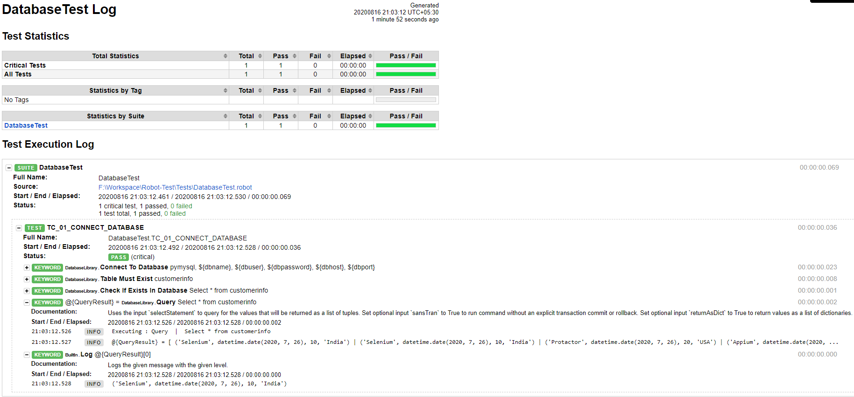

Test Template

Data Driven Testing can be achieved using Test Template
Here in Test 02 I have my data eg one,two,three
& in MULTIPLE VALUES is my [Template] keyword that will accept three arguments and it will execute three times as we have three rows in Test
02_TEST_MULTIPLE_VALUES
[Template] MULTIPLE VALUES
one two three
four five Six
seven eight nine

*** Keywords ***
MULTIPLE VALUES
[Arguments] ${first} ${second} ${three}
log first
log second
log three

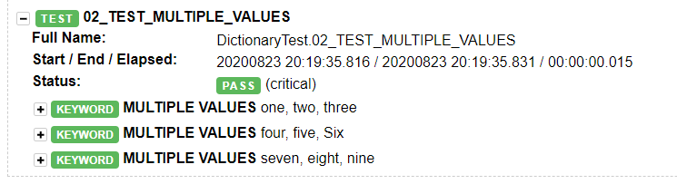

Protractor

Initial commands

Below are the mandatory commands for getting started
npm install -g protractor
webdriver-manager update
webdriver manager start

Reference site

http://seleniumeasy.com/selenium-tutorials/xpath-tutorial-for-selenium
http://santoshsarmajv.blogspot.in/2012/07/how-to-write-xpath.html
http://software-testing-tutorials-automation.blogspot.in/2013/06/xpath-tutorials-identifying-xpath-for.html
Software testing tutorials and automation Xpath Tutorials - Identifying xpath for element with examples to use in selenium.htm
http://www.guru99.com/using-contains-sbiling-ancestor-to-find-element-in-selenium.html
http://www.w3.org/TR/CSS21/selector.html%23id-selectors
https://www.guru99.com/desired-capabilities-selenium.html
http://learn-automation.com/handle-untrusted-certificate-selenium/
http://learn-automation.com/how-to-handle-proxy-in-selenium-webdriver/

